MEGHNAD SAHA INSTITUTE OF TECHNOLOGY

*Techno Complex, Madurdaha,Beside NRI Complex, Post-Uchhepota, Kolkata 700 150*

LABORATORY NOTE BOOK

MAKAUT EVEN SEMESTER 2025



[MASTERS OF COMPUTER APPLICATION]

[OPERATING SYSTEM LAB (UNIX) (MCAN-292)]

[RUPAK SARKAR]

ROLL NO: 14271024036 REGN. NO.: 241420510045

STREAM: MCA SEMESTER: II (2ND)

YEAR: 1ST YearSESSION: 2024-2026



MAULANA ABUL KALAM AZAD UNIVERSITY OF TECHNOLOGY



MEGHNAD SAHA INSTITUTE OF TECHNOLOGY

*Techno Complex,. Madurdaha,Beside NRI Complex, Post-Uchhepota, Kolkata 700 150*

“LIST OF ASSIGNMENT/EXPERIMENT SUBMISSION DETAILS”

|  |  |  |  |  |  |
| --- | --- | --- | --- | --- | --- |
| **SL.**  **NO.** | **ASSIGNMENT / EXPERIMENT NAME** | **DATE OF EXPERIMENT** | **DATE OF SUBMISION** | **CHECKED BY** | **REMARKS (ANY DEVIATION REGARDING SUBMISSION DATES, CONTENT, FORMAT, ETC)** |
| 1. | Cal command in Unix. | 19/02/2025 | 26/02/2025 |  |  |
| 2. | Use of mkdir in Unix. | 19/02/2025 | 26/02/2025 |  |  |
| 3. | Use of rmdir in Unix. | 19/02/2025 | 26/02/2025 |  |  |
| 4. | Cat command in Unix. | 19/02/2025 | 26/02/2025 |  |  |
| 5. | Use of ls command in Unix. | 19/02/2025 | 26/02/2025 |  |  |
| 6. | Use of cp in Unix. | 19/02/2025 | 26/02/2025 |  |  |
| 7. | Vi command in Unix. | 19/02/2025 | 26/02/2025 |  |  |
|  |  |  |  |  |  |
|  |  |  |  |  |  |
|  |  |  |  |  |  |

|  |
| --- |
| OBSERVATIONS / COMMENTS ON THE OVERALL PERFORMANCE: |

Signature in full with date Signature in full with date

**Faculty / Technical Assistant Lab Examiner**

**Q.1. What is the use of Cal command in Unix.**

Ans:

The **cal** command is used to view the calendar.

Output:

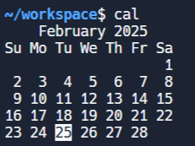

**Q.2. Write the use of mkdir in Unix.**

Ans:

The use of **mkdir** in Unix is to make a new directory or a sub-directory.

Syntax – **mkdir {directory_name}**

Output:

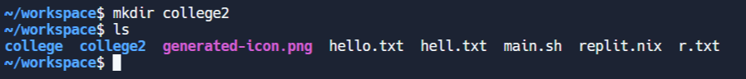

**Q.3. Write the use of rmdir in Unix.**

Ans: The **rmdir** command is used to delete a directory or sub-directory.

Syntax – **rmdir {directory_name}**

Output:

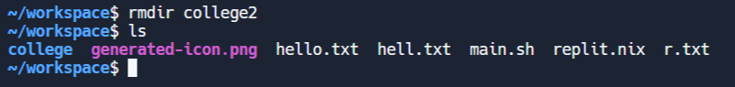

**Q.4. Write the use of cat command in Unix.**

Ans: The **cat** command is used to view the contents of a file.

Syntax – **cat {file_name}**

Output:

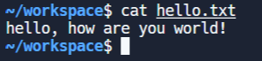

**Q.5. Write the use of ls command in Unix.**

Ans: The **ls** command is used to list all the files and sub-directories in a directory.

Output:



**Q.6. Write the use of cp command in Unix.**

Ans: The **cp** command is used to copy the contents of one file to another.

Syntax – **cp {file_name} {new_file_name}**

Output:

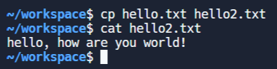

**Q.7. Write the use of vi command in Unix.**

Ans: The **vi** command is used to open and edit existing files. It can also create new files.

Syntax – **vi {file_name}**

Output:

